**ASSIGNMENT – 2**

**Create a Feedback form using HTML (With Internal CSS), it should contain**

**-> Name (optional)**

**-> Email(Optional)**

**-> phone (optional)**

**-> Rating**

**-> Any Questions regarding product or service.**

**-> Additional comments (optional)**

**-> Submit button**

**Feedback.html with Internal CSS**

<!DOCTYPE html>

<html lang="en">

<head>

    <meta charset="UTF-8">

    <meta name="viewport" content="width=device-width, initial-scale=1.0">

    <title>Feedback Form</title>

    <style>

        body {

            font-family: Arial, sans-serif;

            margin: 20px;

        }

        .container {

            width: 50%;

            margin: auto;

            padding: 20px;

            border: 1px solid #ccc;

            border-radius: 10px;

            background-color: #f9f9f9;

        }

        label {

            font-weight: bold;

            display: block;

            margin-top: 10px;

        }

        input, textarea, select {

            width: 100%;

            padding: 8px;

            margin-top: 5px;

            border: 1px solid #ccc;

            border-radius: 5px;

        }

        button {

            margin-top: 15px;

            padding: 10px;

            width: 100%;

            background-color: #28a745;

            color: white;

            border: none;

            border-radius: 5px;

            font-size: 16px;

        }

        button:hover {

            background-color: #218838;

            cursor: pointer;

        }

    </style>

</head>

<body>

    <div class="container">

        <h2>Feedback Form</h2>

        <form action="#" method="post">

            <label for="name">Name (Optional):</label>

            <input type="text" id="name" name="name" placeholder="Enter your name">

            <label for="email">Email (Optional):</label>

            <input type="email" id="email" name="email" placeholder="Enter your email">

            <label for="phone">Phone (Optional):</label>

            <input type="tel" id="phone" name="phone" placeholder="Enter your phone number">

            <label for="rating">Rating:</label>

            <select id="rating" name="rating" required>

                <option value="" disabled selected>Select rating</option>

                <option value="5">Excellent - 5</option>

                <option value="4">Good - 4</option>

                <option value="3">Average - 3</option>

                <option value="2">Poor - 2</option>

                <option value="1">Very Bad - 1</option>

            </select>

            <label for="questions">Any Questions regarding product or service:</label>

            <textarea id="questions" name="questions" rows="4" placeholder="Write your queries here..." required></textarea>

            <label for="comments">Additional Comments (Optional):</label>

            <textarea id="comments" name="comments" rows="3" placeholder="Any additional comments..."></textarea>

            <button type="submit">Submit Feedback</button>

        </form>

    </div>

</body>

</html>

Output:

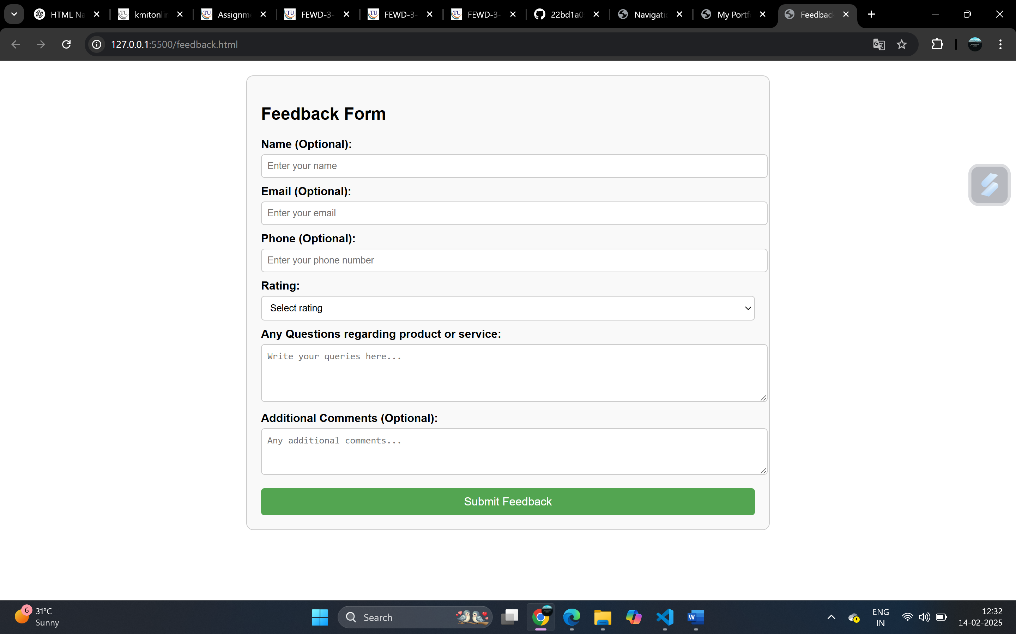

**Feedback.html with external CSS**

<!DOCTYPE html>

<html lang="en">

<head>

<meta charset="UTF-8">

<meta name="viewport" content="width=device-width, initial-scale=1.0">

<title>Feedback Form</title>

<link rel="stylesheet" href="styles.css">

</head>

<body>

<div class="container">

<h2>Feedback Form</h2>

<form action="#" method="post">

<label for="name">Name (Optional):</label>

<input type="text" id="name" name="name" placeholder="Enter your name">

<label for="email">Email (Optional):</label>

<input type="email" id="email" name="email" placeholder="Enter your email">

<label for="phone">Phone (Optional):</label>

<input type="tel" id="phone" name="phone" placeholder="Enter your phone number">

<label for="rating">Rating:</label>

<select id="rating" name="rating" required>

<option value="" disabled selected>Select rating</option>

<option value="5">Excellent - 5</option>

<option value="4">Good - 4</option>

<option value="3">Average - 3</option>

<option value="2">Poor - 2</option>

<option value="1">Very Bad - 1</option>

</select>

<label for="questions">Any Questions regarding product or service:</label>

<textarea id="questions" name="questions" rows="4" placeholder="Write your queries here..." required></textarea>

<label for="comments">Additional Comments (Optional):</label>

<textarea id="comments" name="comments" rows="3" placeholder="Any additional comments..."></textarea>

<button type="submit">Submit Feedback</button>

</form>

</div>

</body>

</html>

**Styles.css**

/* General Styles */

body {

font-family: Arial, sans-serif;

margin: 20px;

background-color: #f4f4f4;

}

.container {

width: 50%;

margin: auto;

padding: 20px;

border: 1px solid #ccc;

border-radius: 10px;

background-color: #fff;

}

/* Labels and Inputs */

label {

font-weight: bold;

display: block;

margin-top: 10px;

}

input, textarea, select {

width: 100%;

padding: 8px;

margin-top: 5px;

border: 1px solid #ccc;

border-radius: 5px;

}

/* Submit Button */

button {

margin-top: 15px;

padding: 10px;

width: 100%;

background-color: #28a745;

color: white;

border: none;

border-radius: 5px;

font-size: 16px;

}

button:hover {

background-color: #218838;

cursor: pointer;

}

/* Portfolio Styles */

h1, h2 {

color: #333;

}

ul {

list-style-type: square;

padding-left: 20px;

}

a {

text-decoration: none;

color: #007bff;

}

a:hover {

text-decoration: underline;

}

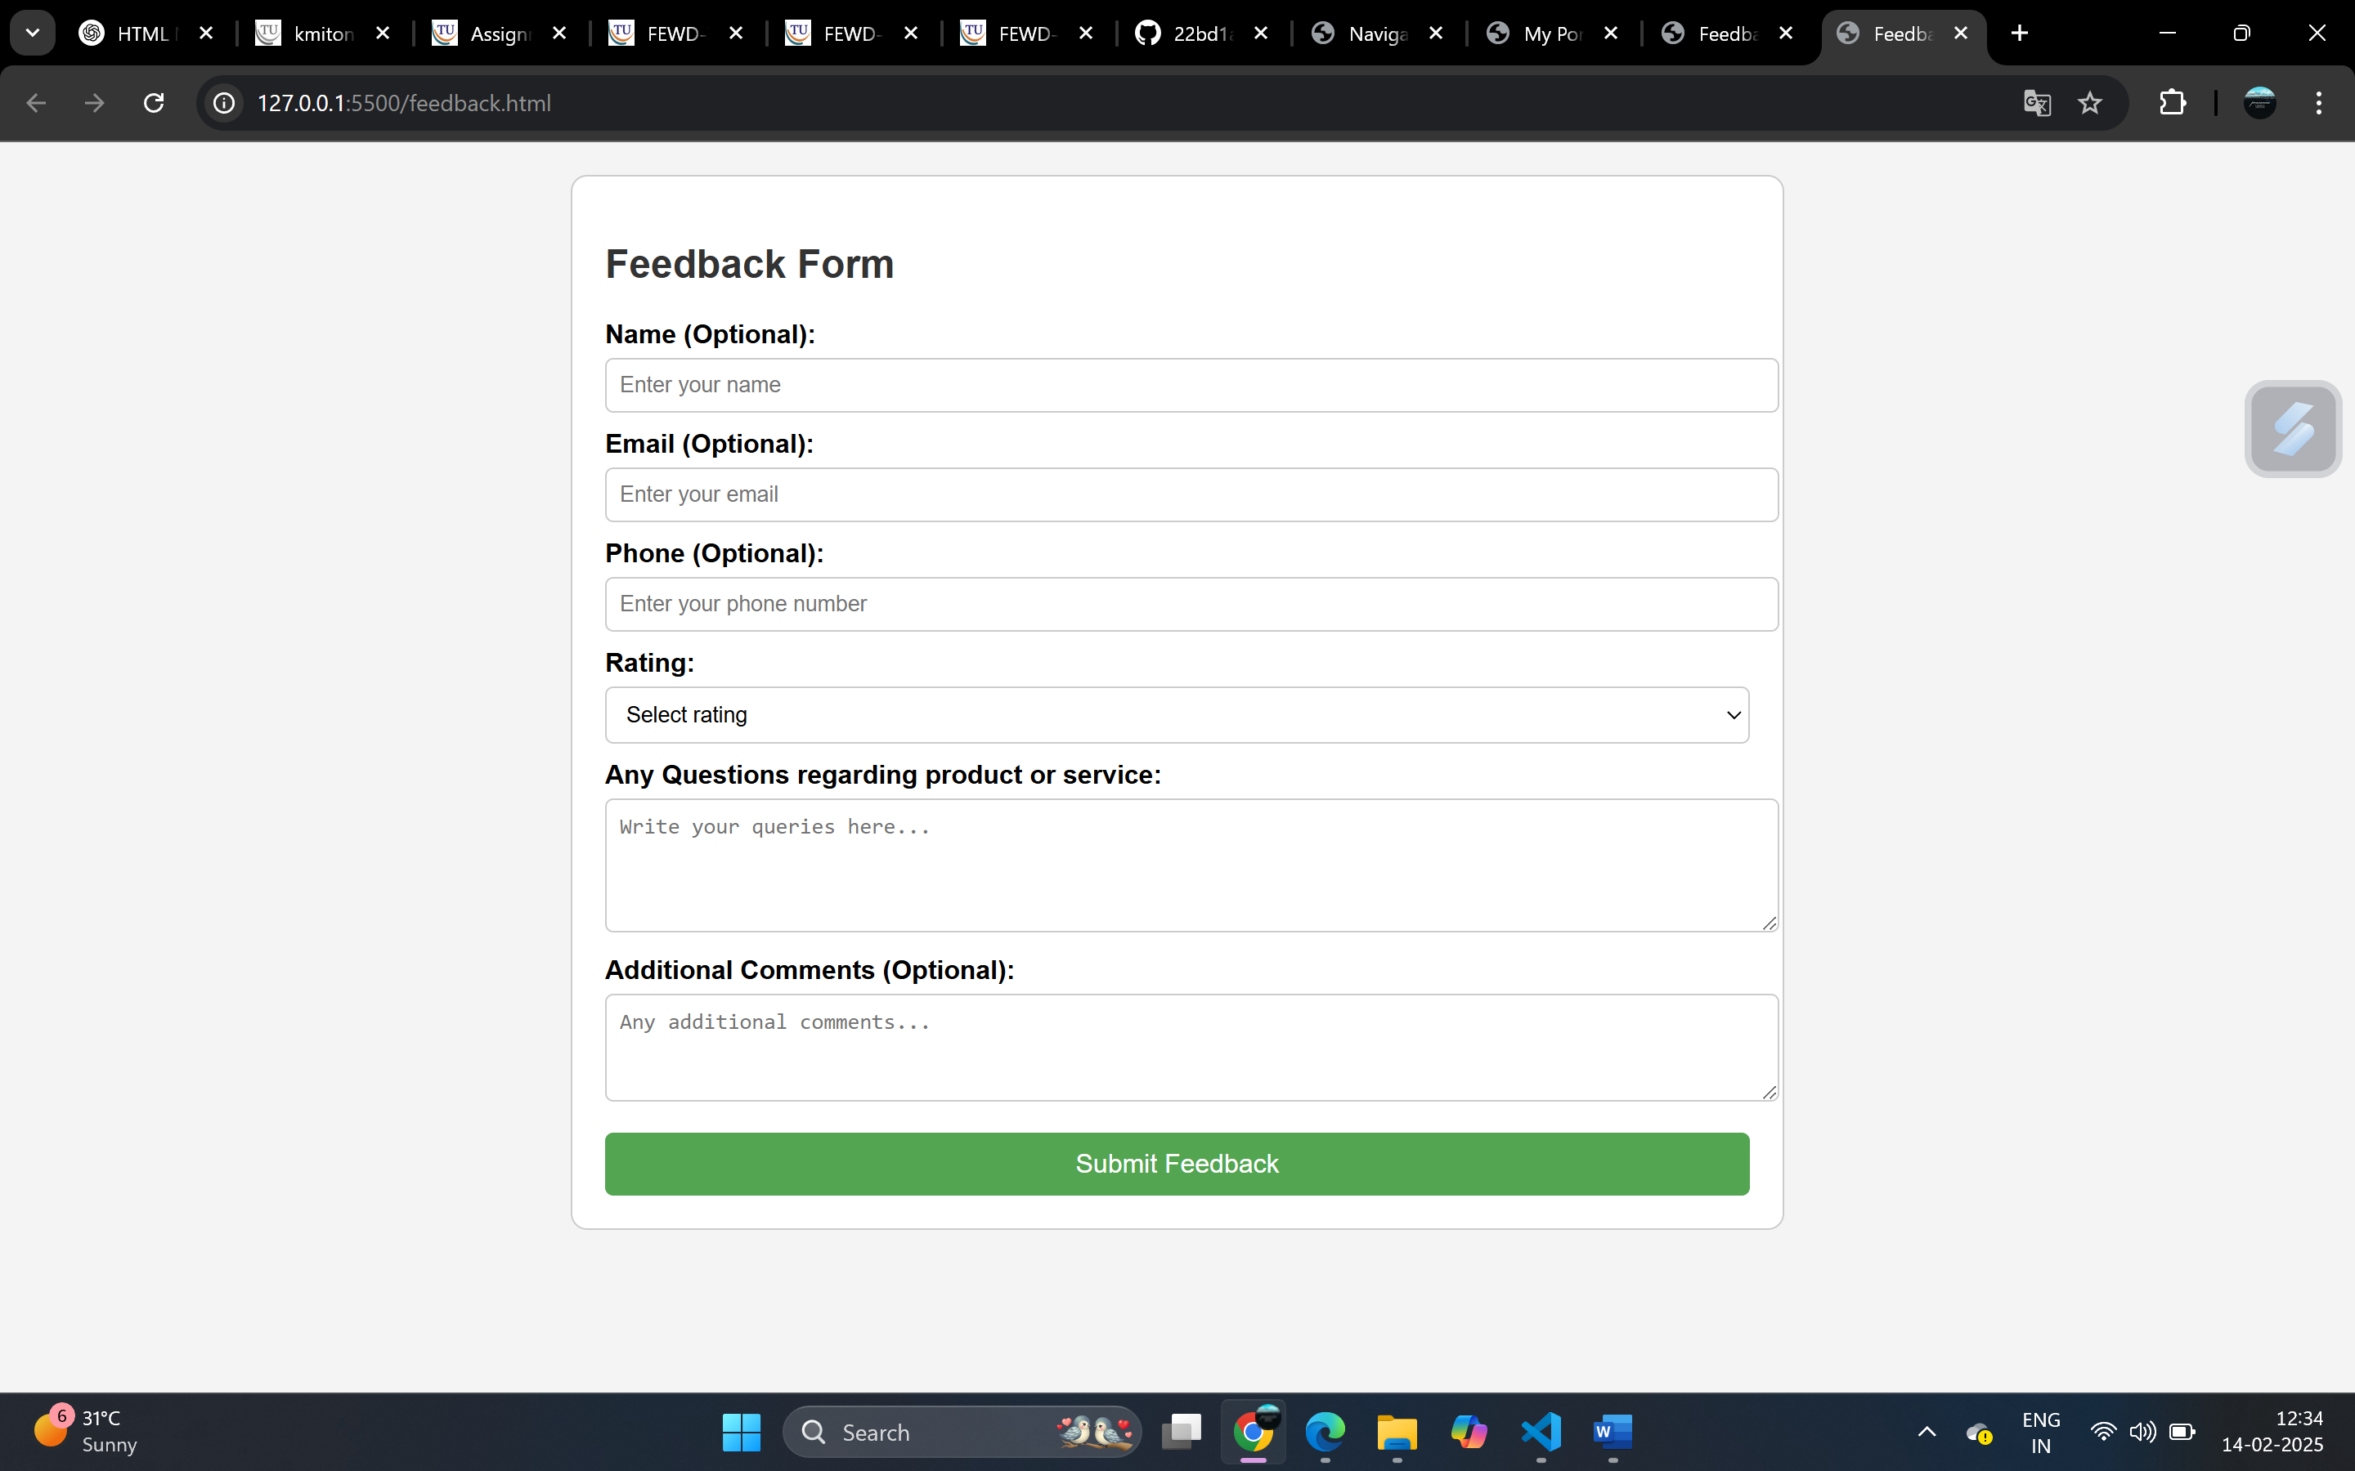

**Portfolio.html with external CSS**

<!DOCTYPE html>

<html lang="en">

<head>

    <meta charset="UTF-8">

    <meta name="viewport" content="width=device-width, initial-scale=1.0">

    <title>My Portfolio</title>

    <link rel="stylesheet" href="styles.css">

</head>

<body>

    <header>

        <h1>My Portfolio</h1>

        <p>Web Developer | Full Stack Engineer | Problem Solver</p>

    </header>

    <nav>

        <ul>

            <li><a href="#about">About Me</a></li>

            <li><a href="#skills">Skills</a></li>

            <li><a href="#projects">Projects</a></li>

            <li><a href="#achievements">Achievements</a></li>

            <li><a href="#education">Education</a></li>

            <li><a href="#contact">Contact</a></li>

        </ul>

    </nav>

    <main>

        <section id="about">

            <h2>About Me</h2>

            <p>Hello! I am <strong>Sadhika Prasanna</strong>, a passionate **Full Stack Developer** with experience in building dynamic and responsive web applications.</p>

        </section>

        <section id="skills">

            <h2>Skills</h2>

            <ul>

                <li>Frontend: HTML, CSS, JavaScript, React, Next.js</li>

                <li>Backend: Node.js, Express.js, Flask</li>

                <li>Databases: MongoDB, MySQL</li>

                <li>Version Control: Git, GitHub</li>

            </ul>

        </section>

        <section id="projects">

            <h2>Projects</h2>

            <ul>

                <li><a href="https://github.com/sadhikaprasanna/MechAI-Chatbot" target="_blank">Project 1 - E-Commerce App</a></li>

                <li><a href="https://github.com/sadhikaprasanna/prescription-qrcode-generation" target="_blank">Project 2 - Chatbot AI</a></li>

            </ul>

        </section>

        <section id="achievements">

            <h2>Achievements & Feedback</h2>

            <p>Recognized for optimizing database queries, reducing load time by 50%. Received 5-star ratings from clients for delivering scalable solutions.</p>

        </section>

        <section id="education">

            <h2>Education</h2>

            <p>Bachelor's in Computer Science, <strong>Keshav Memorial Institute of Technology</strong></p>

        </section>

        <section id="contact">

            <h2>Contact Me</h2>

            <ul>

                <li>Email: <a href="sadhikaprasanna@gmail.com">your.email@example.com</a></li>

                <li>Phone: +1234567890</li>

                <li>GitHub: <a href="https://github.com/sadhikaprasanna" target="_blank">Your GitHub</a></li>

                <li>LinkedIn: <a href="https://linkedin.com/in/sadhikaprasanna" target="_blank">Your LinkedIn</a></li>

            </ul>

        </section>

    </main>

    <footer>

        <p>© 2025 Sadhika Prasanna. All rights reserved.</p>

    </footer>

</body>

</html>

**Styles.css**

body, h1, h2, p, ul {

    margin: 0;

    padding: 0;

    font-family: Arial, sans-serif;

}

/* Basic layout */

body {

    background-color: #f4f4f4;

    color: #333;

    line-height: 1.6;

    text-align: center;

}

/* Header */

header {

    background: #0073e6;

    color: white;

    padding: 20px;

}

/* Navigation Bar */

nav ul {

    list-style: none;

    background: #222;

    padding: 10px;

}

nav ul li {

    display: inline;

    margin: 0 15px;

}

nav ul li a {

    color: white;

    text-decoration: none;

    font-weight: bold;

}

/* Section Styling */

section {

    margin: 20px auto;

    padding: 20px;

    max-width: 800px;

    background: white;

    border-radius: 8px;

    box-shadow: 0px 0px 10px rgba(0, 0, 0, 0.1);

}

h2 {

    color: #0073e6;

}

/* Footer */

footer {

    background: #222;

    color: white;

    padding: 10px;

    margin-top: 20px;

}

